**ABCD MALL**

**Address Book**

# DEVELOPER GUIDE

|  |  |  |
| --- | --- | --- |
| **Supervisor** | Tooba Khawar | |
| **Batch** | 2111G1 | |
| **Group** | A | |
| **Serial No** | **Enrollment Number** | **Student Name** |
| **1.** | Std1342540 | AHMED FARAZ. |
| **2.** | Std1331509 | MUHAMMAD KALEEM AHMED SIDDIQUI. |
| **3.** | Std1332457 | MUHAMMAD WAJAHAT KHAN. |
| **4.** | Std1345169 | UMAR NASAR. |
|  |  |  |

**1. Home Page**

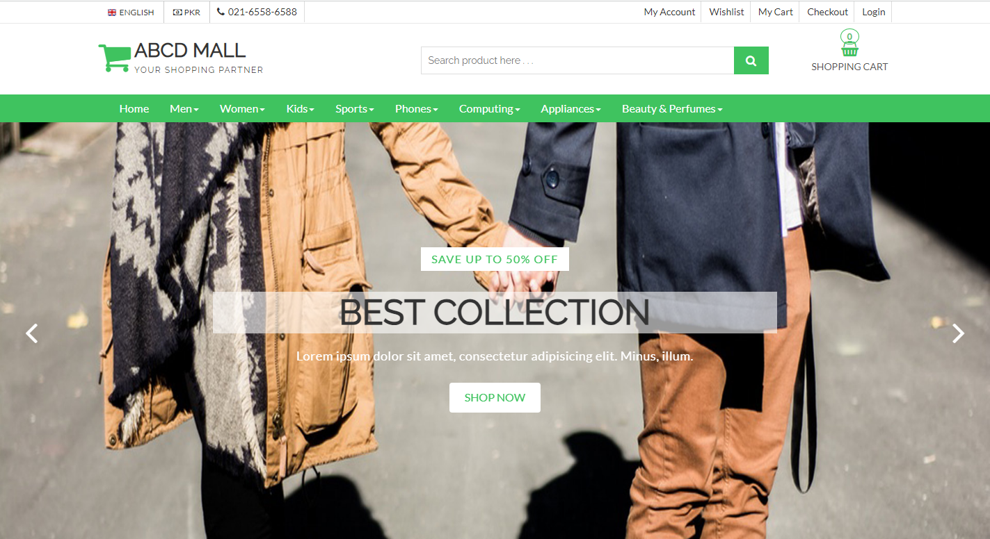1

User opens the website and is welcomed with a sleek homepage.

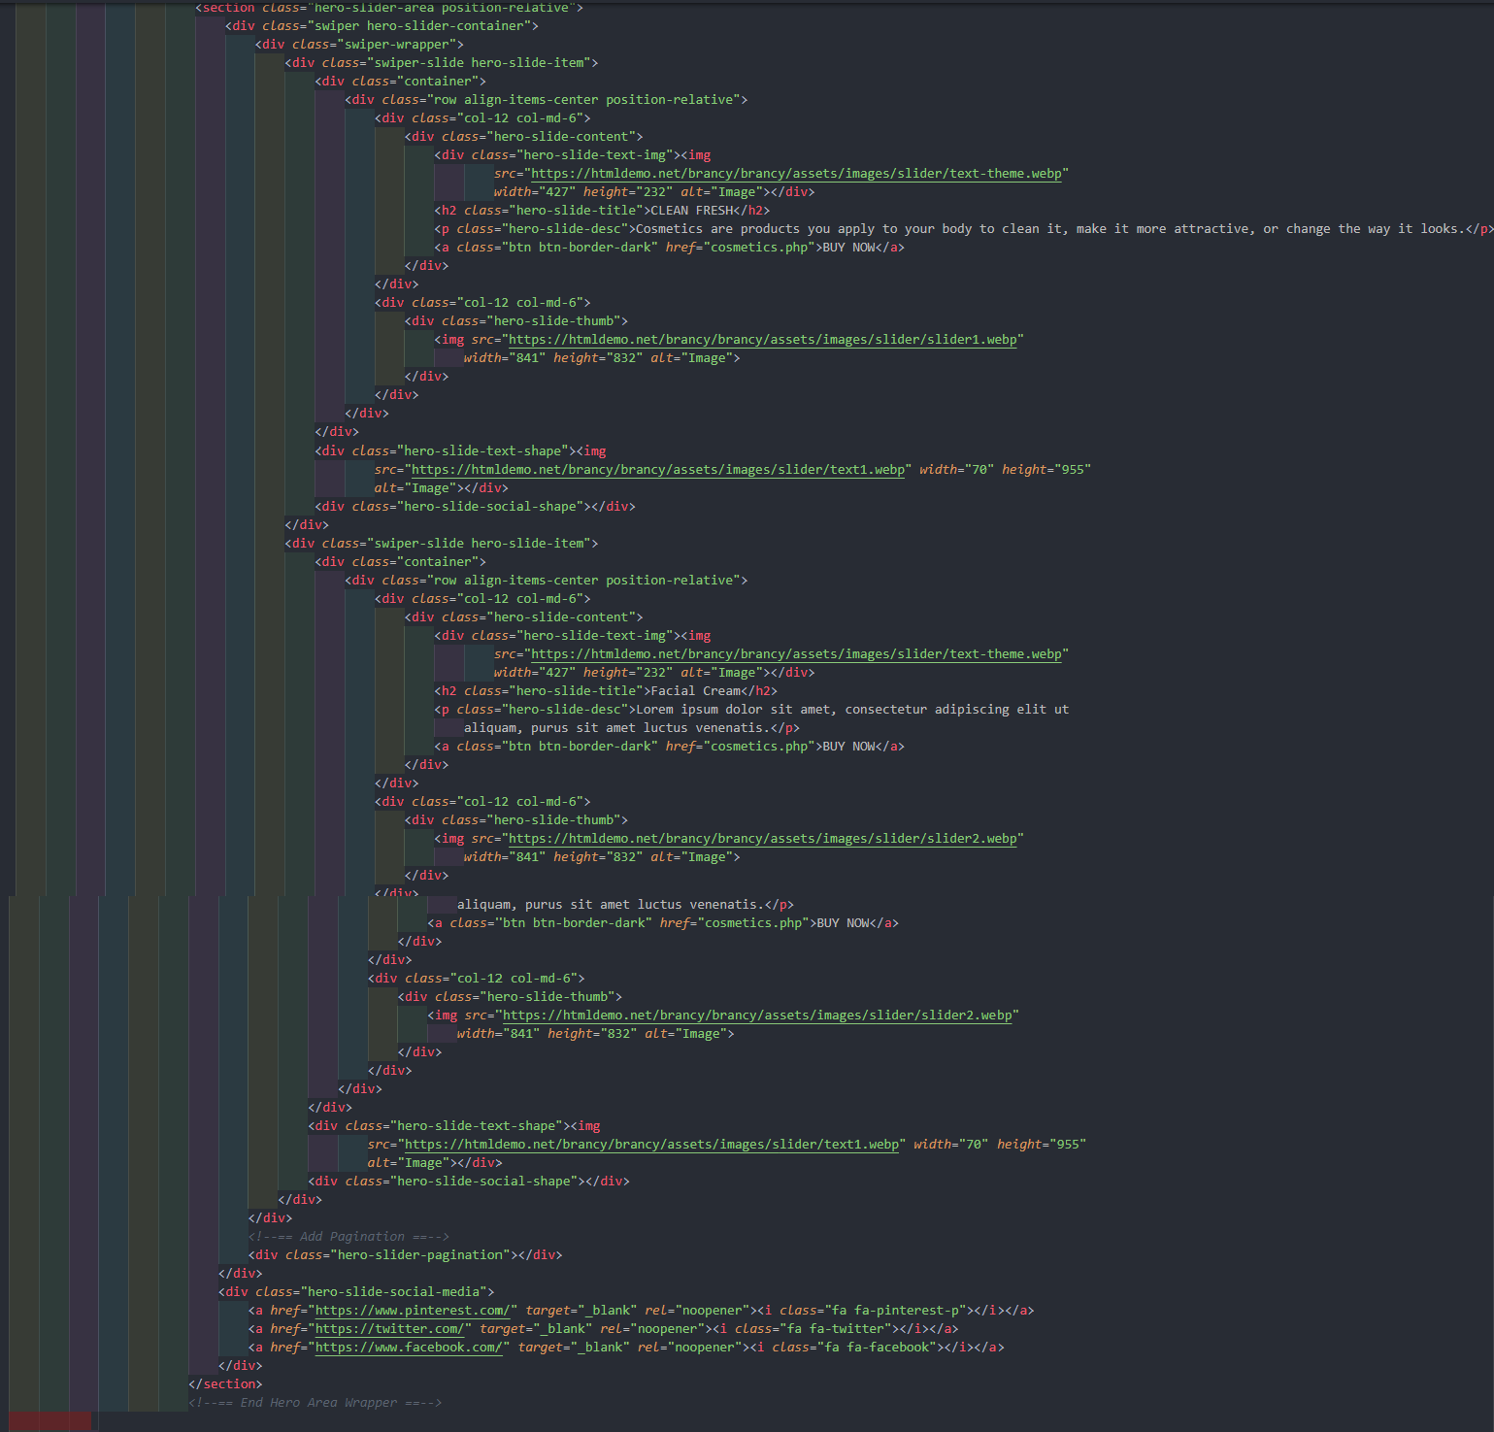

**1.1 Layout Top (Header)**

Website has a header section with brand logo at left, and a navigation bar at middle with all the quick links for user to explore the website and navigate pages easily.

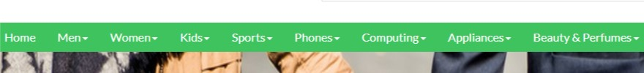

## Menu Bar

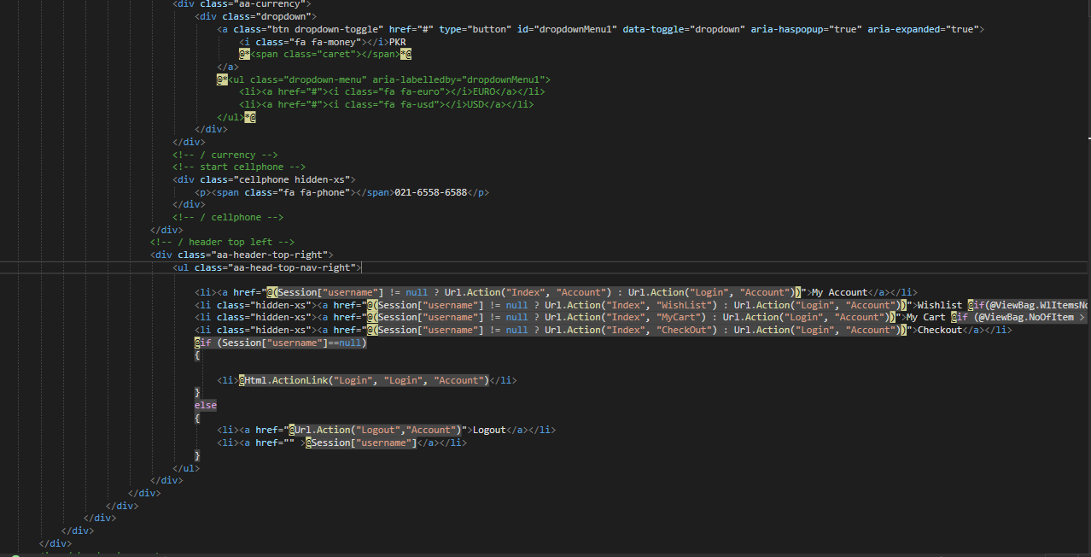

Search: User can click on it to open search modal and search for products. Account: User can click on It to signup/login to account.

Cart: Cart popup and redirect link to cart page Menu: Side bar Menu

**1.2 Layout Bottom (Footer)**

Footer section is provided on the website with website info , a menu with links to load other pages, contact information (address, email, and phone number) and payment Icons

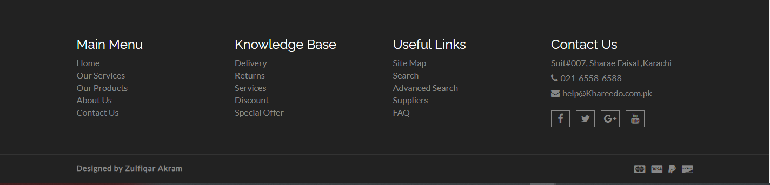

## 1.2.1 Icons

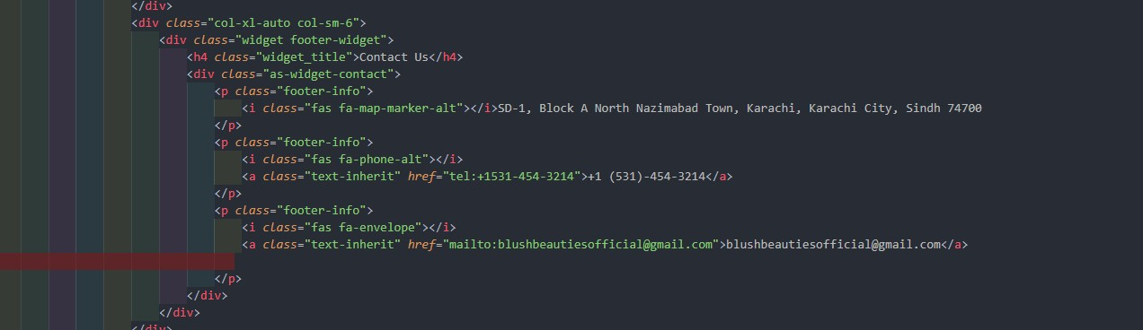

# SECTIONS

**1.3 Slideshow**

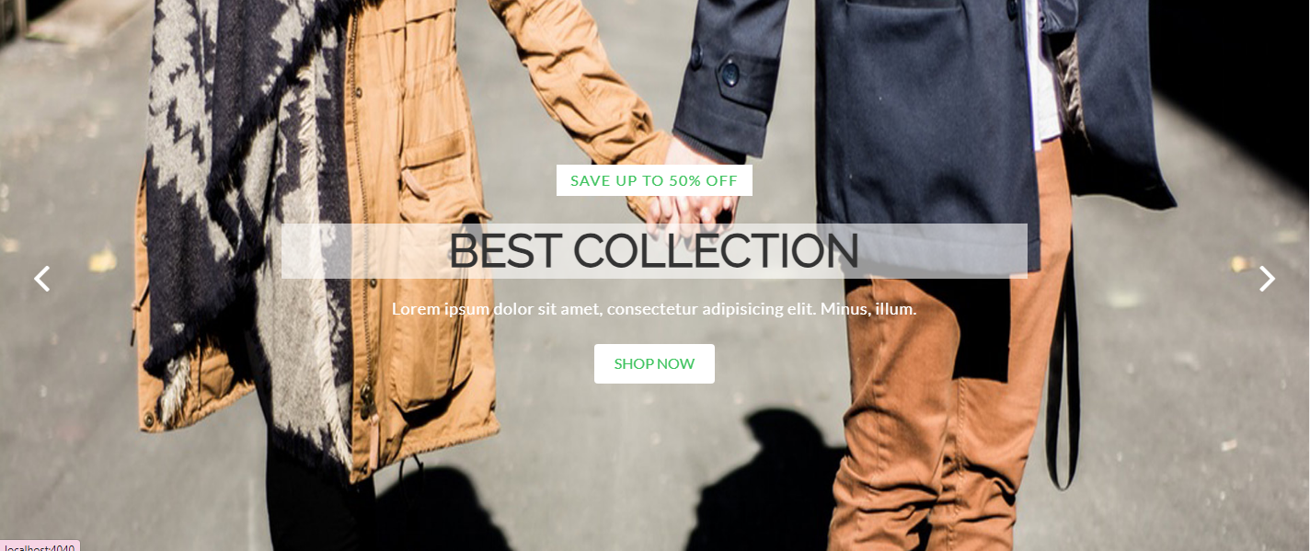

This section has 4 banners with text on it and user can click on Buy now to go to Cosmetics collection page.

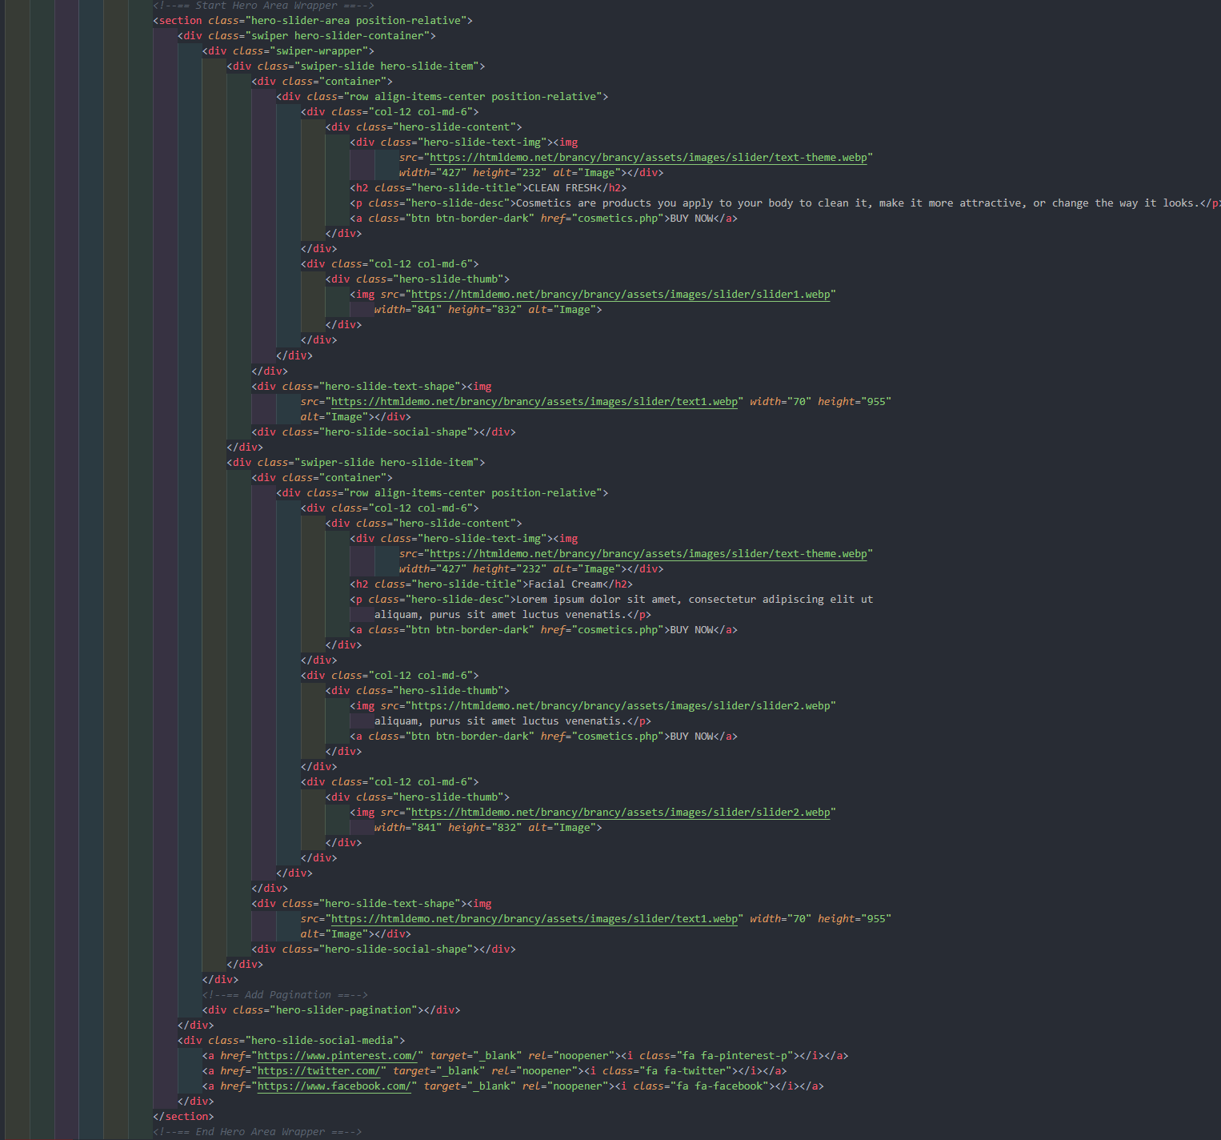

**1.4 Our Collection of Men and Women**

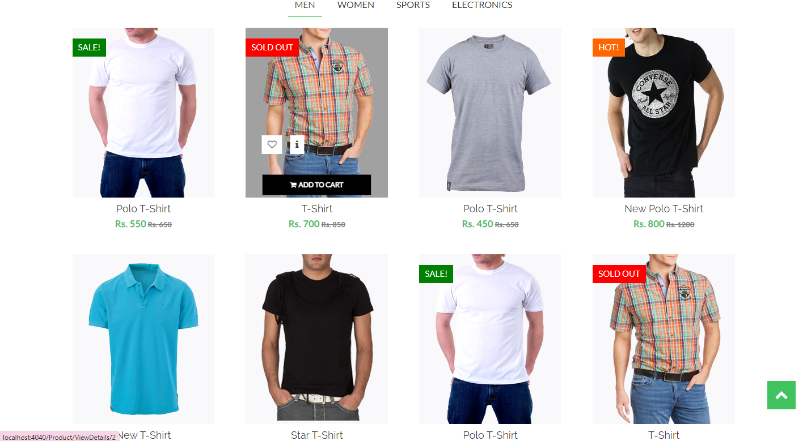

This section show the collection of men.

User can click to buy the product “ADD TO CART”.

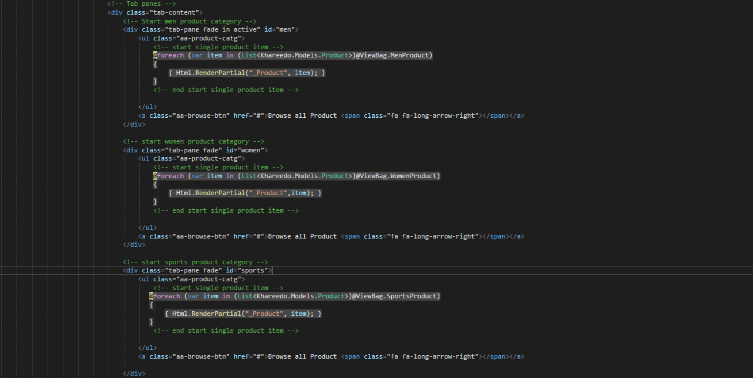

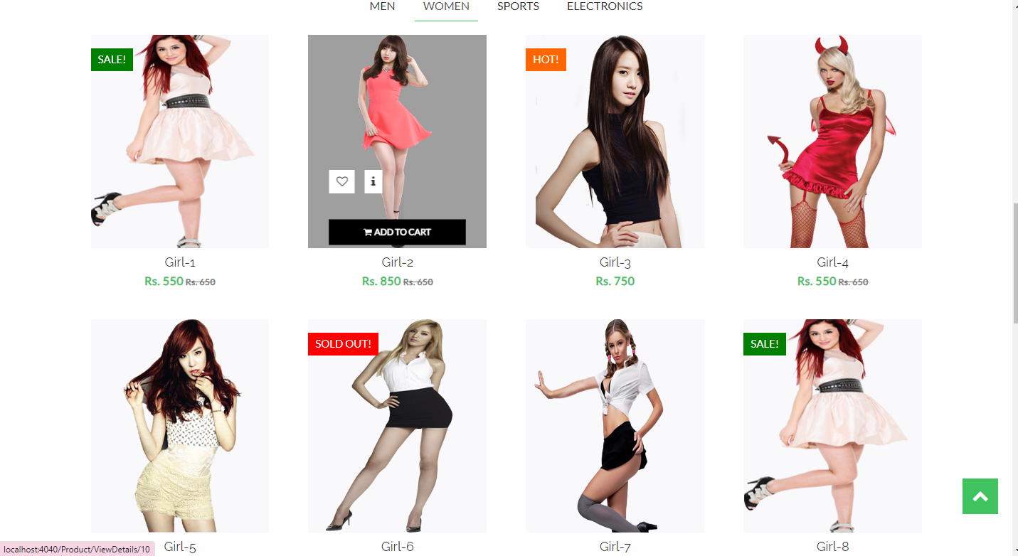

This section show the collection of women.

User can click to buy the product “ADD TO CART”.

**1.5 CheckOut**

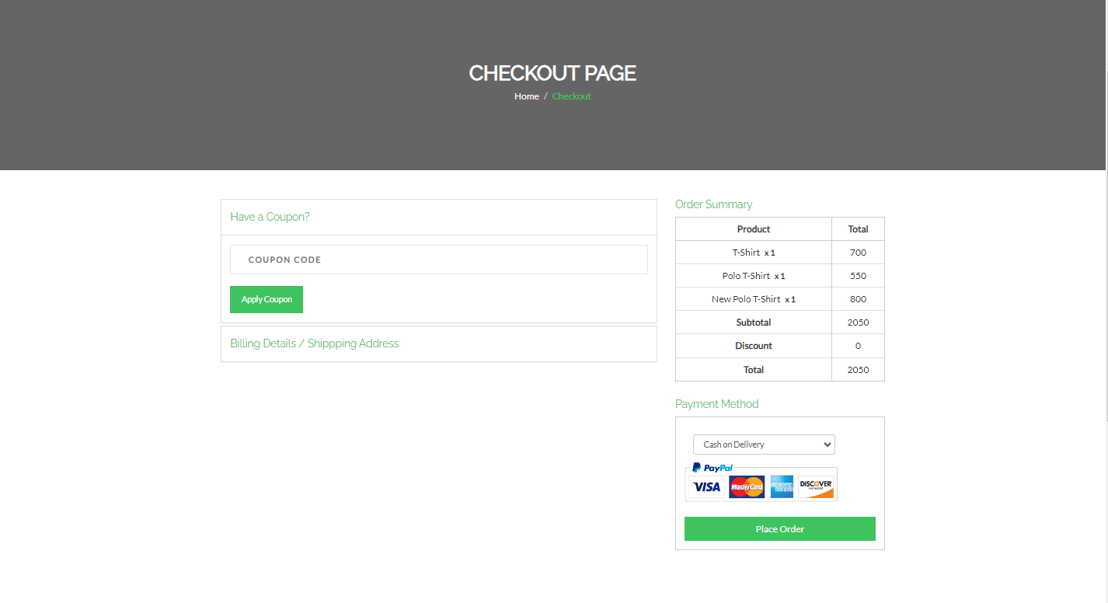

User click the button “ADD TO CART” the product move to checkout page to buy product.

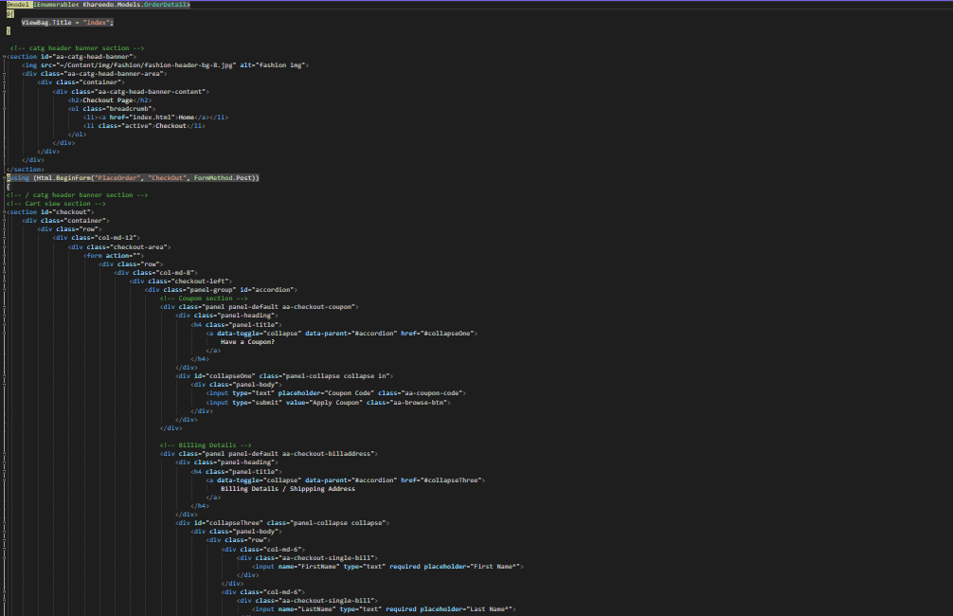

**1.6 Gallery Slider**

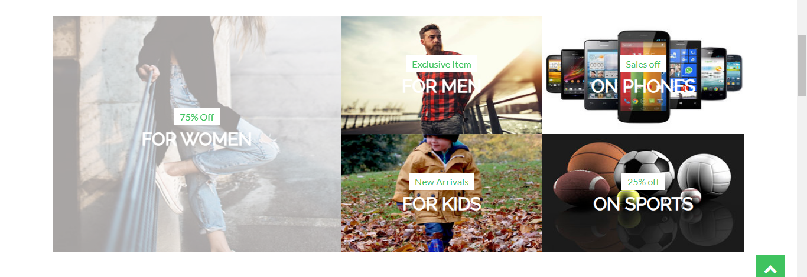

## 1.7.1 Product Card

## 

User can click on Title or Image to go to the specific product page.

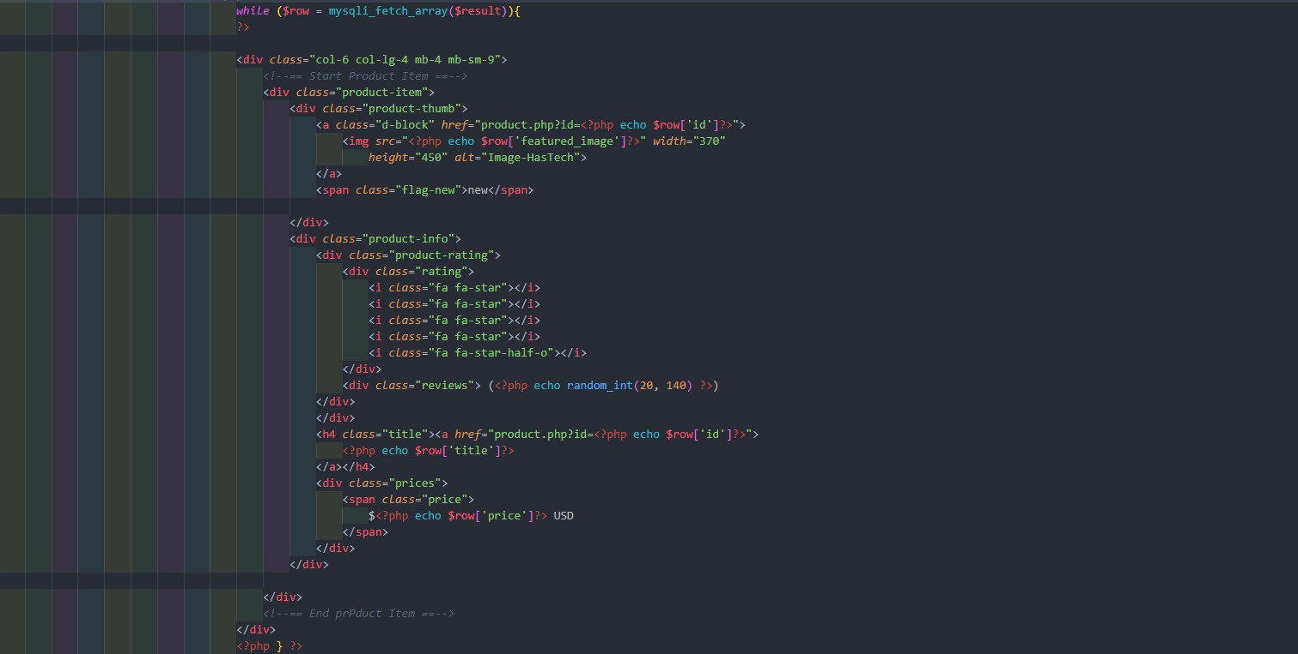

**1.8 Promotional Text**

**1.10 Newsletter**

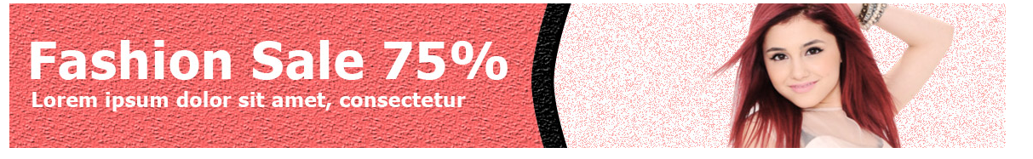

This newsletter section has 2 images and a form to collect user email for marketing. User can enter their email and upon submission they will receive a confirmation email.

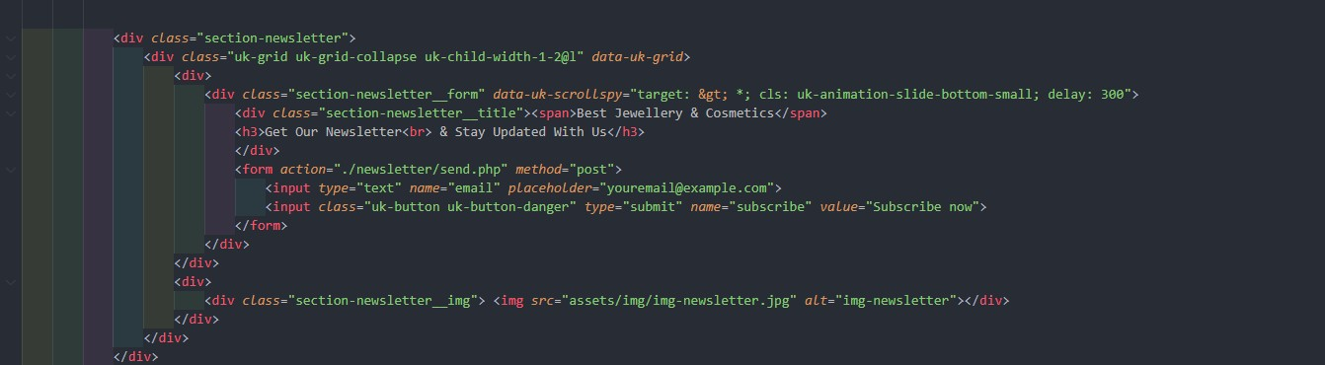

**1.11 Instagram Gallery**

**2. Cosmetics Page (Collection Type Page)**

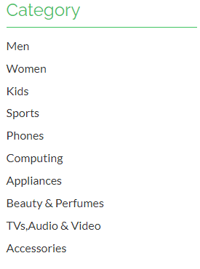

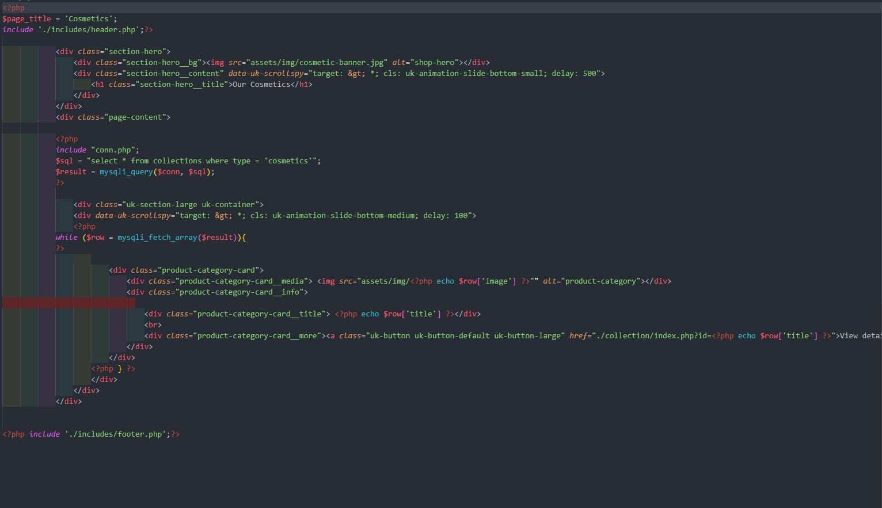

## Product Card

User can click on Title or Image to go to the specific product page.

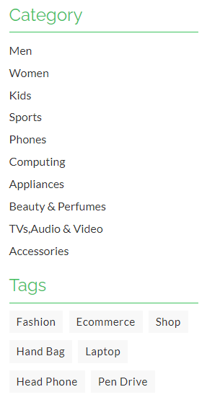

* + 1. **Search**



User can search for products using the search bar.

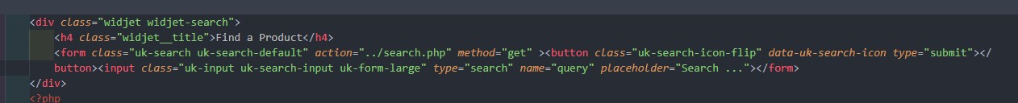

## Search

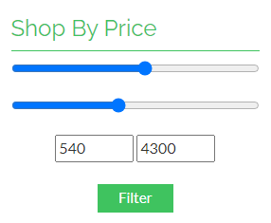

User can filter the products based on price range.

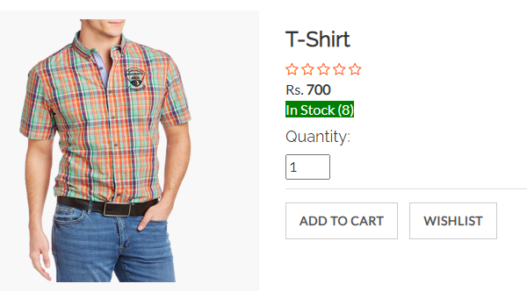

**4. Product Page**

**5. Cart Page**

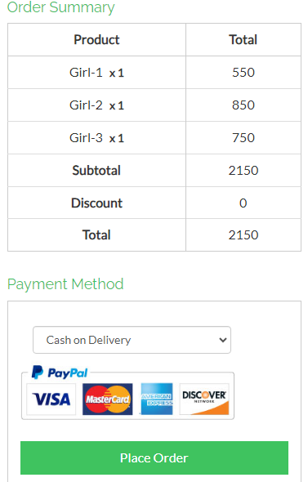

On Cart page user can see their cart and check the final price and go to checkout.

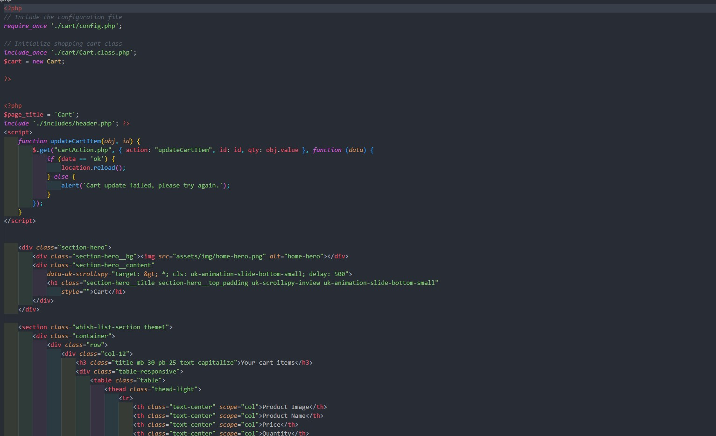

# ADMIN

**1. Main Page**

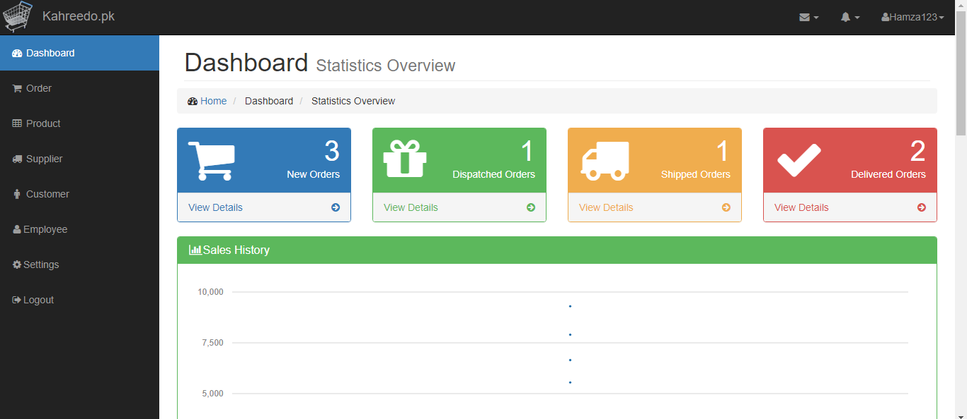

**3. Products**

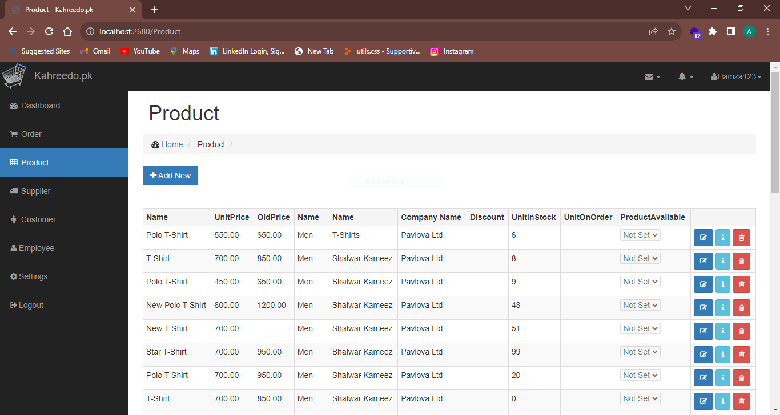

**6. Orders**

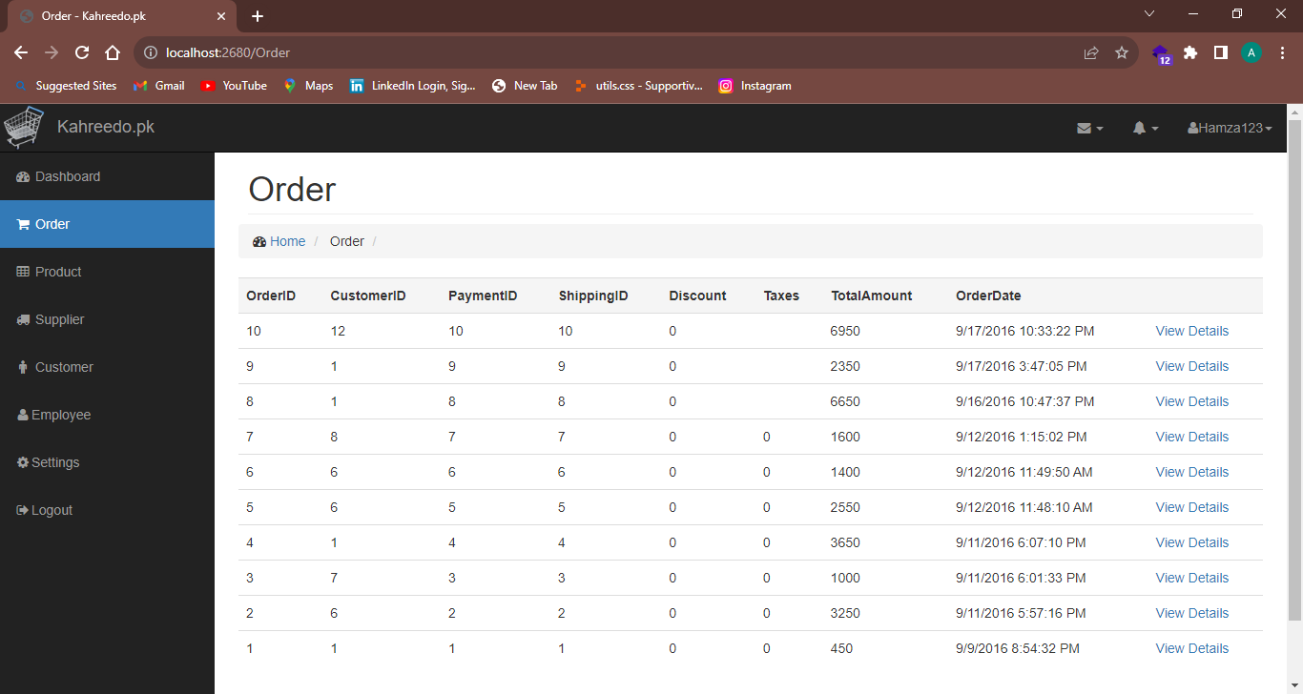

Admin can edit a specific product

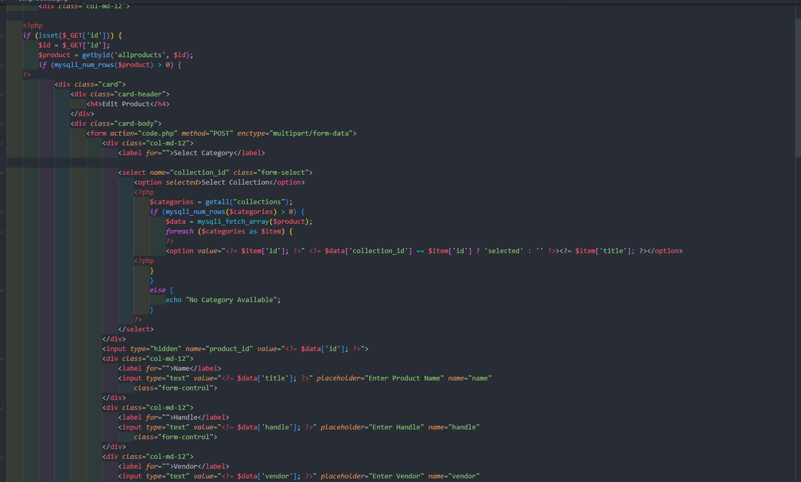

**11. Login Page**

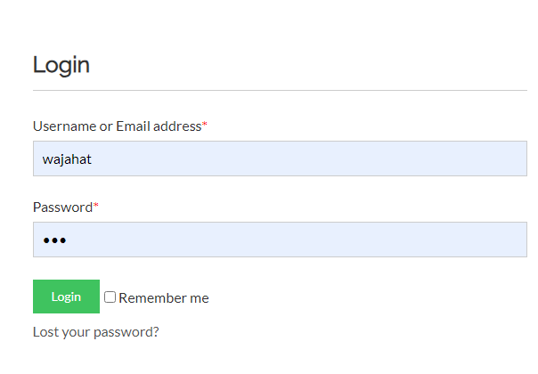

User Can Login to their account or navigate to Sign Up page to register for account. Following are the test accounts.

Admin Login:

email: [admin@blushbeauties.com](mailto:admin@blushbeauties.com) Password: admin

User Login:

Email: [john@gmail.com](mailto:john@gmail.com) Password: pakistan

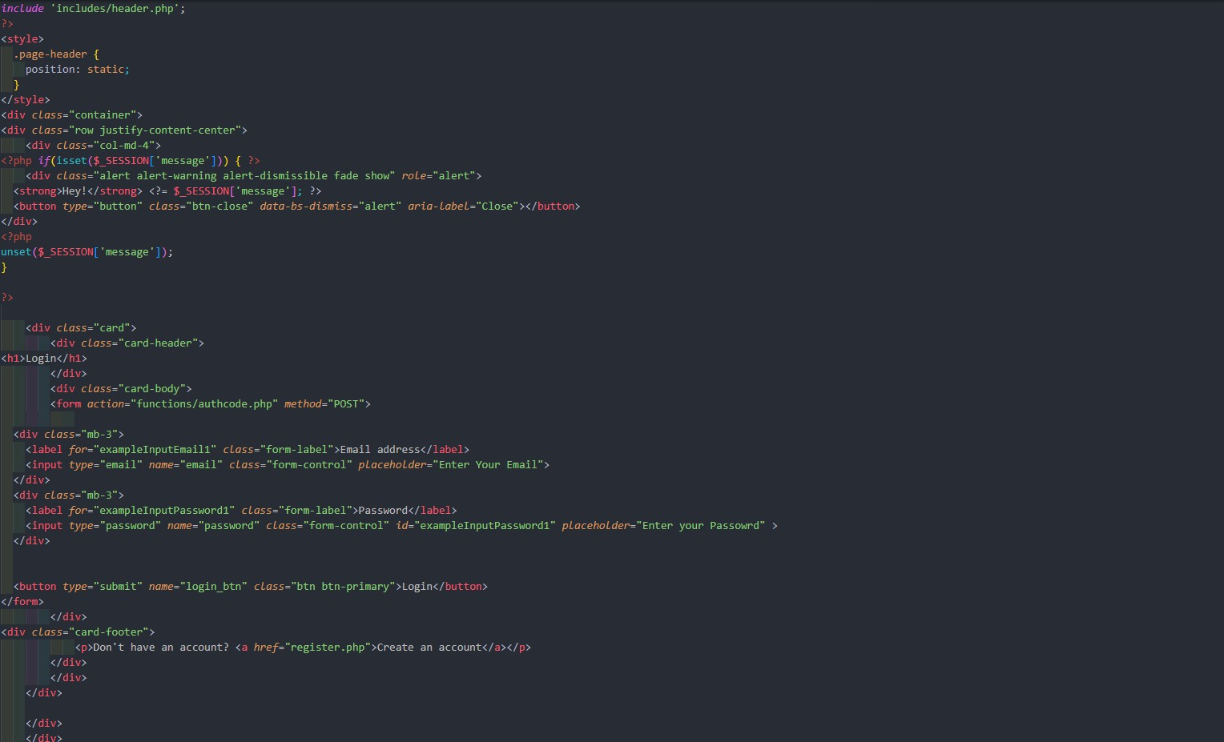

**12. Signup Page - Register an account**

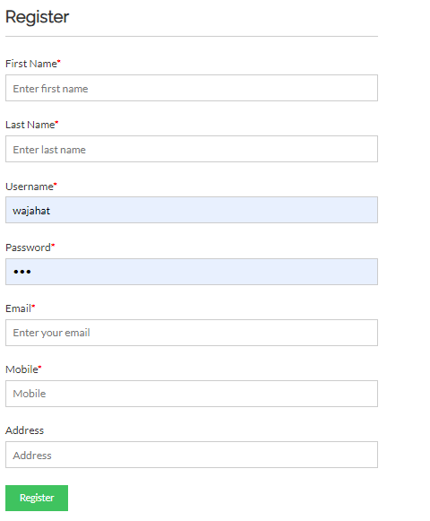

User can signup for an account

